Unit 10 HW Solutions

## Question 1 (Note R code is immediately below and SAS code appears after Question 2)

Black-eared wheatears are small birds of Spain and Morocco. Males of the species demonstrate an exaggerated sexual display by carrying many heavy stones to nesting cavities. This 35-gram bird transports, on average, 3.1 kg of stones per nesting season! Different males carry somewhat different sized stones, prompting a study of whether larger stones may be a signal of higher health status. M. Soler et al. calculated the average stone mass (g) carried by each of 21 male black-eared wheatears, along with T-cell response measurements (in mm) reflecting their immune system strengths. Analyze the data and write a statistical report (by answering the questions below); treat the T-cell as the response and the stone mass as the explanatory variable. You may assume all criteria for regression and related t-tests are met. You can find the data for this problem in the file session10Data.xlsx. You may use R or SAS.

Analyze the data, providing the following:

### Part A (6 points)

Provide a scatterplot with 99% confidence intervals of the regression line and 99% prediction intervals of the regression line.

display <- read.csv("C:/Users/Charles/Documents/SMU/Online Teaching/MSDS 6371 - Statistical Foundations for Data Science/UNIT 10/Male Display Data Set.csv")  
  
##Initial scatterplot  
plot(display[,1], display[,2], xlim = c(0, 13), ylim =c(0, 0.7), xlab = "Mass",   
ylab = "Tcell", main = "Tcell versus Mass")  
displayDF <- data.frame(display)  
  
##Regression Model  
displaylm <- lm(Tcell ~ Mass, data = display)  
  
##Add the regression line to the existing scatterplot  
abline(displaylm, col = "red")  
  
##Create "new" data to make confidence and prediction intervals  
newx <- displayDF$Mass  
newx <- sort(newx)  
  
##Confidence Interal  
prd_c <- predict(displaylm, newdata = data.frame(Mass = newx), interval = c("confidence"),   
type = c("response"), level = .99)   
  
##Prediction Interval  
prd_p <- predict(displaylm,newdata = data.frame(Mass = newx), interval = c("predict"),   
type = c("response"), level = .99)  
  
##Add prediction and confidence intervals to the scatterplot  
lines(newx, prd_c[,2], col = "blue", lty = 2, lwd = 2)  
lines(newx,prd_c[,3], col = "blue", lty = 2, lwd = 2)  
lines(newx,prd_p[,2], col = "green", lty = 2, lwd = 2)  
lines(newx,prd_p[,3], col = "green", lty = 2, lwd = 2)

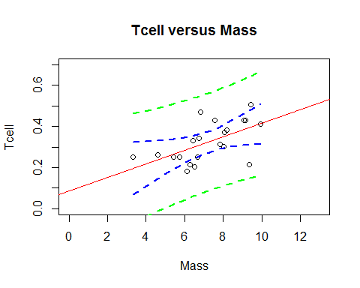

### Part B (2 points)

Provide a table showing the t-statistics and p-values for the significance of the regression parameters $β_{0}$ and $β_{1}$ (as different from 0).

summary(displaylm)

##   
## Call:  
## lm(formula = Tcell ~ Mass, data = display)  
##   
## Residuals:  
## Min 1Q Median 3Q Max   
## -0.18138 -0.04673 0.01796 0.04219 0.15999   
##   
## Coefficients:  
## Estimate Std. Error t value Pr(>|t|)   
## (Intercept) 0.08750 0.07868 1.112 0.27996   
## Mass 0.03282 0.01064 3.084 0.00611 **  
## ---  
## Signif. codes: 0 '***' 0.001 '**' 0.01 '*' 0.05 '.' 0.1 ' ' 1  
##   
## Residual standard error: 0.08102 on 19 degrees of freedom  
## Multiple R-squared: 0.3336, Adjusted R-squared: 0.2986   
## F-statistic: 9.513 on 1 and 19 DF, p-value: 0.006105

### Part C (12 points)

Using the output in (b), show all 6 steps of each hypothesis test. (That’s one test for $β_{0}=0$ and one test for $β_{1}=0$). Find critical values in R. Your conclusion should include a confidence interval. Use alpha = 0.01.

confint(displaylm, level=0.99)

## 0.5 % 99.5 %  
## (Intercept) -0.137591407 0.31258537  
## Mass 0.002376893 0.06326609

qt(0.995, 21-2)

## [1] 2.860935

**First, the slope (though order doesn’t matter).**

**(1 point) Step 1 - Hypotheses:**

$$H_{o}:β_{1}=0$$

$$H_{a}:β_{1}≠0$$

**(1 point) Step 2 - Identification of Critical Value: $t_{0.995,21-2}=±2.86$**

**(1 point) Step 3 - Value of Test Statistic: $t=3.08$:**

**(1 point) Step 4 - Give p-value: $p=0.0061$**

**(1 point) Step 5 - Decision: Reject $H_{o}$**

**(1 point) Step 6 - Conclusion: There is sufficient evidence at the $α=0.01$ level of significance ( $p=0.0061$ from the t-test) to conclude that there is a linear relationship between the average stone mass and Tcell response. A 99% confidence interval for the slope of the regression line is $0.03282±2.86⋅0.01064=[0.0024,0.0633]$.**

**Next, the intercept.**

**(1 point) Step 1 - Hypotheses:**

$$H_{o}:β_{0}=0$$

$$H_{a}:β_{0}≠0$$

**(1 point) Step 2 - Identification of Critical Value: $t_{0.995,21-2}=±2.86$**

**(1 point) Step 3 - Value of Test Statistic: $t=1.11$:**

**(1 point) Step 4 - Give p-value: $p=0.28$**

**(1 point) Step 5 - Decision: Fail to Reject $H_{o}$**

**(1 point) Step 6 - Conclusion: There is not sufficient evidence at the $α=0.01$ level of significance ( $p=0.28$ from the t-test) to conclude that the y-intercept is not equal to 0. A 99% confidence interval for this value is $0.0875±2.86⋅0.07868=[-0.1376,0.3126]$.**

### Part D (2 points)

State the regression equation. Be careful to use the mean Tcell or predicted Tcell, rather than just Tcell.

*Note: Either option below is acceptable.*

$${\overset{^}{μ}}_{TCell}=0.0875+0.03282⋅Mass$$

$$\overset{^}{TCell}=0.0875+0.03282⋅Mass$$

### Part E (2 points)

Interpret the slope in the model (regression equation).

**For every increase of 1 gram in the stone mass, the estimated T-cell response increases by 0.03282 mm.**

### Part F (2 points)

Interpret the y-intercept in the model (regression equation).

**When the stone mass is equal to 0, the estimated T-cell response is 0.0875 mm.**

### Part G (4 points)

Find and interpret the 99% **confidence** interval for the mean t-cell response conditional on a stone mass of 4.5 grams.

*Note: 2 points for the interval, 2 points for the interpretation.*

newpoint <- data.frame(Tcell=NA, Mass=4.5)  
predict(displaylm, newpoint, interval="confidence", level=0.99)

## fit lwr upr  
## 1 0.2351937 0.1385665 0.3318209

**With 99% confidence, the mean t-cell response for a stone mass of 4.5 grams is between 0.139 and 0.332.**

### Part H (4 points)

Find and interpret the 99% **prediction** interval for the predicted t-cell response conditional on a stone mass of 4.5 grams.

*Note: 2 points for the interval, 2 points for the interpretation.*

newpoint <- data.frame(Tcell=NA, Mass=4.5)  
predict(displaylm, newpoint, interval="prediction", level=0.99)

## fit lwr upr  
## 1 0.2351937 -0.01593192 0.4863193

**A 99% prediction interval for a t-cell response given a stone mass of 4.5 grams is -0.016 to 0.486.**

### Part I (3 points)

Provide a scatterplot of residuals.

displayres <- resid(displaylm)  
plot(display$Mass, displayres, ylab="Residuals", xlab="Mass", main="Residuals versus Mass")  
abline (0,0)

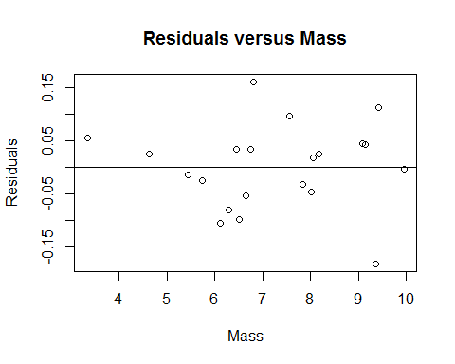

### Part J (3 points)

Provide a histogram of residuals with a normal distribution superimposed. It might be helpful to use studentized residuals, rather than regular residuals, with a normal curve overlay. (You may need to research this, such as googling “histogram with normal curve in R.”)

##Store studentized residuals  
studresdisplay <- rstudent(displaylm)  
  
##Histogram  
hist(studresdisplay, freq=FALSE, main="Distribution of Studentized Residuals",   
xlab="Studentized Residuals", ylab="Density", ylim=c(0,0.5))  
  
##Create range of x-values for normal curve  
xfit <- seq(min(studresdisplay), max(studresdisplay), length=40)  
  
##Generate values from the normal distribution at the specified values  
yfit <- (dnorm(xfit))  
  
##Add the normal curve  
lines(xfit, yfit, ylim=c(0,0.5))

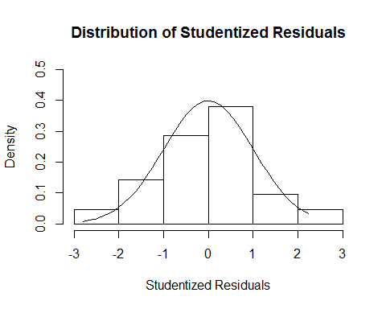

**Additional Resource:** [**https://www.r-bloggers.com/visualising-residuals/**](https://www.r-bloggers.com/visualising-residuals/)

### Part K (2 points)

Provide a measure of the **proportion** of variation in the response that is accounted for by the explanatory variable. **Interpret** this measure.

cor(display$Mass, display$Tcell)^2

## [1] 0.3336345

**33.363% of the variation in Tcell response is accounted for by the mass.**

## Question 2 (40 points total)

Using the data for Black-eared Wheatears, calculate by “hand” (using Excel) the following elements. (An example of much of this was in the PowerPoints and in the videos below.)

### Part A (8 points)

${\overset{^}{β}}_{0}$ and ${\overset{^}{β}}_{1}$

*Note: 4 points are for ${\overset{^}{β}}_{0}$ and 4 points are for ${\overset{^}{β}}_{1}$. You can receive partial credit if you make a mistake but have some of the process correct.*

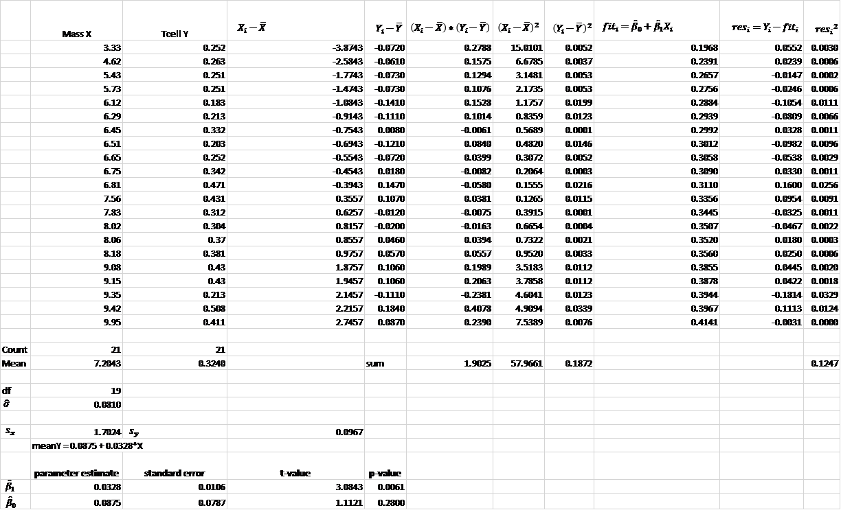

### Part B (4 points)

The t-statistics and p-values for the hypothesis tests $β_{0}=0$ and $β_{1}=0$.

**See above. Give 1 point for each test statistic and p-value.**

### Part C (7 points)

99% confidence intervals for the mean of Y when X = {3,4,5,6,7,8,9} grams

*Note from part 1c that the t-multiplier is 2.8609. Assign 1 point for each confidence interval.*

|  |  |  |  |  |
| --- | --- | --- | --- | --- |
| $$X_{0}$$ | $$\overset{^}{Y}∥X_{0}$$ | $SE({\overset{^}{μ}}_{Y}∥X_{0})$) | 99% Lower Confidence Limits | 99% Upper Confidence Limits |
| 3 | 0.1860 | 0.0481 | 0.0483 | 0.3236 |
| 4 | 0.2188 | 0.0384 | 0.1089 | 0.3287 |
| 5 | 0.2516 | 0.0294 | 0.1676 | 0.3356 |
| 6 | 0.2844 | 0.0218 | 0.2220 | 0.3469 |
| 7 | 0.3172 | 0.0178 | 0.2663 | 0.3682 |
| 8 | 0.3501 | 0.0196 | 0.2940 | 0.4062 |
| 9 | 0.3829 | 0.0260 | 0.3084 | 0.4574 |

### Part D (7 points)

99% prediction intervals for the predicted Y when X = {3,4,5,6,7,8,9} grams.

*Again, assign 1 point for each confidence interval.*

|  |  |  |  |  |
| --- | --- | --- | --- | --- |
| $$X_{0}$$ | $$\overset{^}{Y}∥X_{0}$$ | $SE(\overset{^}{y}∥X_{0})$) | 99% Lower Prediction Limits | 99% Upper Prediction Limits |
| 3 | 0.1860 | 0.0942 | -0.0836 | 0.4555 |
| 4 | 0.2188 | 0.0897 | -0.0377 | 0.4753 |
| 5 | 0.2516 | 0.0862 | 0.0050 | 0.4982 |
| 6 | 0.2844 | 0.0839 | 0.0444 | 0.5245 |
| 7 | 0.3172 | 0.0830 | 0.0799 | 0.5546 |
| 8 | 0.3501 | 0.0834 | 0.1116 | 0.5885 |
| 9 | 0.3829 | 0.0851 | 0.1394 | 0.6264 |

### Part E (2 points)

Provide a plot for the confidence intervals and prediction intervals using Excel. Fully label your graph. (Use the regression equation and parts (c) and (d) above to create the plot.)

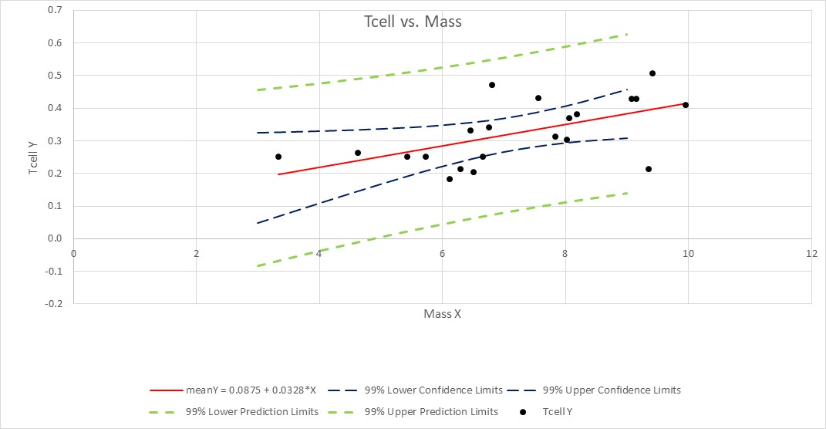

### 

### Question 1 Using SAS

### Part A

Repeat 1 (a) using SAS.

*Q3 Parts a,b,c;  
proc glm data = displaydata plots = all alpha = 0.01;  
model Tcell=mass / solution clparm;  
run;

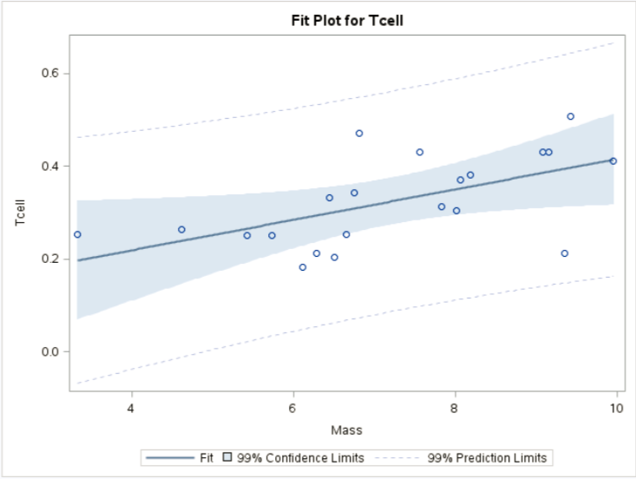

### Part B

Repeat 1 (b) using SAS.

### Part C

Repeat 1 (c) using SAS.

*To get critical values for hypothesis tests;  
data mycritval;  
cv = quantile(“t”, 0.995, 21-2);  
run;

proc print data = mycritval;  
run;



*Note: the results for the test should be exactly the same, just verify the output in SAS.*

### Part D, E, F (+1 point)

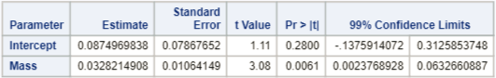

### Part G,H

*To create a record with mass = 4.5 but missing Tcell;  
data display2;  
input Mass Tcell;  
datalines;  
4.5 .  
;  
run;

proc print data = display2;  
run;

*To add the dummy record to the original display set;  
data combined;  
set displaydata display2;  
run;

proc print data = combined;  
run;

*To get confidence intervals and prediction intervals at every value of mass (especially 4.5, which is what we are looking for);  
proc reg data = combined alpha = 0.01;  
model Tcell=mass / clm cli;  
run;

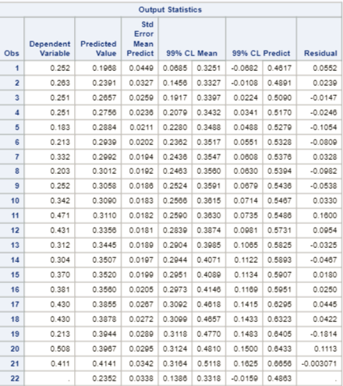

**A 99% confidence interval for the mean Tcell when mass = 4.5 g is (0.1386 mm, 0.3318 mm).**

*Note: output is above.*

**A 99% prediction interval for an individual Tcell when mass = 4.5 g is (-0.0159 mm, 0.4863 mm).**

### Part I

Repeat 1 (j) using SAS.

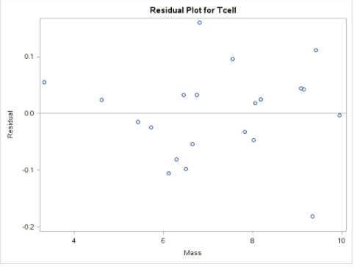

### Part J

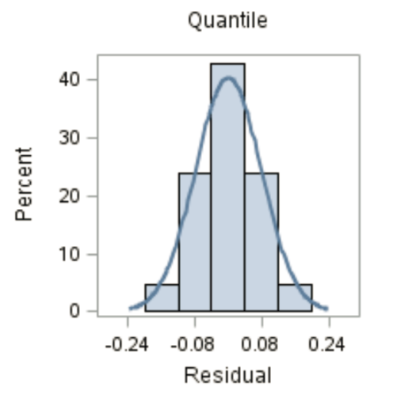

**There is no evidence against residuals being normally distributed.**

### Part K

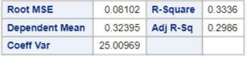

**The percent of variation in Tcell that can be explained by the mass is 33.36%.**

Videos for using Excel:

${\overset{^}{β}}_{0}$ and : <http://screencast.com/t/ztSxTImiOk6s>

SE of ${\overset{^}{β}}_{0}$ and ${\overset{^}{β}}_{1}$ and RMSE: <http://screencast.com/t/V9gnhSwb>

Confidence Intervals: <https://www.screencast.com/t/ELiUGTe7Kc>

Prediction Intervals: <https://www.screencast.com/t/ap8WETxsGUqN>

CI and PI Plotting: <https://www.screencast.com/t/efrpHrqgYZnG>

Calibration Mean Gross: <https://www.screencast.com/t/Yu7eqiiH0X>

Calibration Single Movie: <https://www.screencast.com/t/2vS1lGqtJ>